Bridgepoint Parts Catalog

Section II: Chemical Systems Page 1
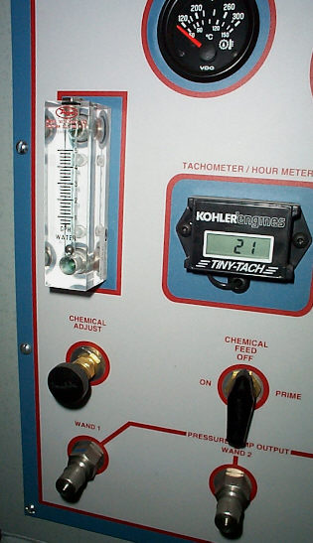

Chemical System Parts - Prochem & White Magic
PP41-809158 Chemical Pump SS – Complete New Style
BR259 Elbow 90˚ 1/4” Flare x 1/8”mpt - Brass
BR280 Elbow 90˚ 1/8” Street - Brass
BR017 Barb 5/16” x 1/8”mpt - Brass
BR124 Coupler 1/4” Flare x 1/8”mpt - Brass
XAF2 5/16” ID Chemical Hose
PP15-808106 Metering Valve (Right Angle Fittings)
PP15-808028 Metering Valve (Straight Fittings)
NM3005 3 way Valve
PP18-808513 Chemical Flow Meter
PP18-808522 Chemical Flow Meter with Knob
BR070 1/8” Close Nipple - Brass
PP12-800261 Elbow 45°1/4” Flare x 1/8”mpt - Brass
PP15-808094 Outlet Check Valve Assembly – Prochem
PWM-B221 Check Valve – Inline 1/4” Stainless Steel
NA0840 Strainer – Acorn 1/8” FPT

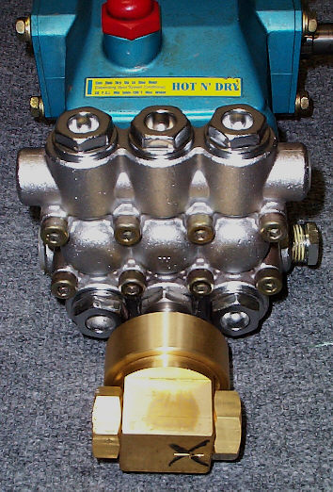

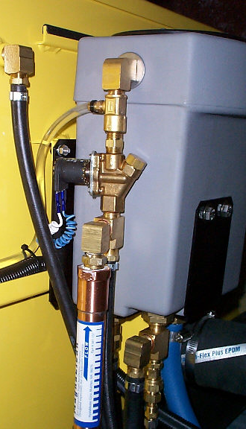

Chemical System Parts – Hydramaster – Siphon
BR030 Barb 1/2” x 3/8”mpt - Brass
BR280 Elbow 90˚ 1/8” Street - Brass
BR010 Barb 1/4” x 1/8”mpt - Brass
BR282 Elbow 90˚ 1/4” Street - Brass
PHY181-008 Venturi – Low PSI Injector
PHY074-020 Chemical Flow Meter with Knob – Modified
PP18-808522 Chemical Flow Meter with Knob
PHY169-120 Solenoid Valve
PHY157-022 Relay
PHY157-0012 Float Switch – Tethered
PHY157-031 Float Switch – Side Mount w/ Bulkhead Fitting
BR074 3/8” Hex Nipple - Brass
XAF1 1/4” ID Vinyl Tubing – Chemical Hose
BR284 Elbow 90˚ 3/8” Street - Brass
BR294 Elbow 90˚ 3/8” F-F - Brass
BR286 Elbow 90˚ 1/2” Street - Brass
PHY052-019 Swivel Fitting 6M-6UFS
PHY169-062 1/4” Anti Siphon Valve
PHY169-061 3/8” Anti Siphon Valve

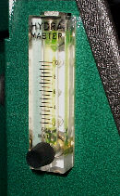

PP52-809125
PHY001-082

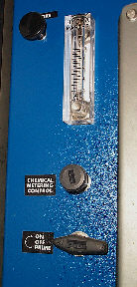

Chemical System Parts – Hydramaster –Last Step
BR259 Elbow 90˚ 1/4” Flare x 1/8”mpt - Brass
BR280 Elbow 90˚ 1/8” Street - Brass
BR018 Barb 3/8” x 1/8”mpt - Brass
BR282 Elbow 90˚ 1/4” Street - Brass
BR124 Fitting 1/4” Flare x 1/8”mpt - Brass
PHY111-035 Chemical Pump – Complete
PHY074-028 Chemical Flow Meter - Modified
PA053 3/8” ID Chemical Hose
PHY169-017 3-Way Valve
PP15-808028 Metering Valve (Straight)
PHY169-175 Check Valve 3/8” FPT – Brass (Maxx, Javelin, & Boxxer 421)
PHY169-186 Check Valve 3/8” FPT – (CDS 4.6, 4.8 & Boxxer 427)
PCE290-08 Strainer – Acorn 1/4” FPT

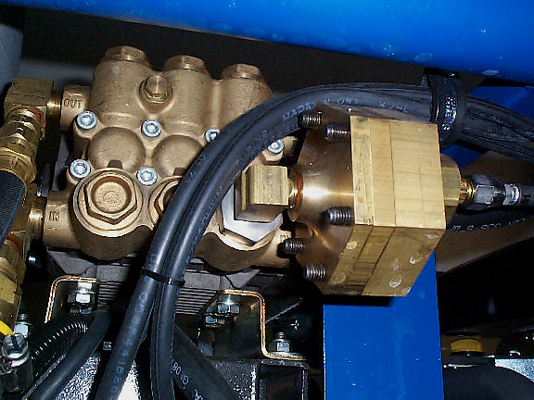

Bridgepoint Parts Catalog

Section II: Chemical Systems Page 2

PHY111-035 Chemical Pump Hydramaster
Old Style Chemical Pump
PP42-809265 Check Valve and O-ring
PHY046-010 Diaphragm
BR259 Elbow 90˚ 1/4” Flare x 1/8”mpt - Brass
BR280 Elbow 90˚ 1/8” Street - Brass
BR018 Barb 3/8” x 1/8”mpt - Brass
BR282 Elbow 90˚ 1/4” Street - Brass
BR124 Fitting 1/4” Flare x 1/8”mpt - Brass
PHY001-096 Adapter – Hydra Pump II
PHY001-082 Adapter – Cat Pump & Hydra Pump V
PHY106-110 Plug – Check Valve - Brass
PHY143-152 Screw – Soc. HD 5/16”-24 x 1-1/2”
PHY097-055 O-ring – Mid Plate
PHY097-056 O-ring – Check Valve Plug
PHY064-015 Cover - Brass
PHY105-071 Mid Plate – Brass
PHY111-030 Body - Brass
PHY169-176 Valve Chem Pump Shutoff
PA053 3/8” ID Chemical Hose

PHY111-025 Chemical Pump

BR259

Elbow 90° 1/8” mpt x 1/4” Flare

PHY106-110

Plug Check Valve - Brass

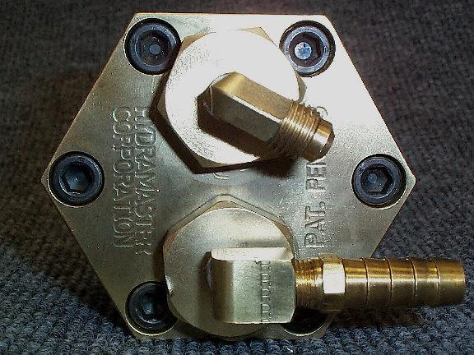

PHY143-152

Screw (1 of 6)

BR018

Barb 3/8” x 1/8” mpt

PHY064-015

Cover - Brass

BR280

Elbow 90° 1/8” Street

PHY046-010

Diaphragm

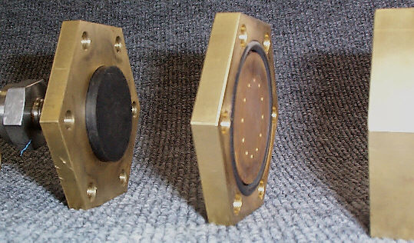

PHY111-030

Body - Brass

PHY105-071

Mid Plate - Brass

PHY097-055

O-ring -Mid Plate

PHY001-082

Adapter Cat Pump

PP41-809158 Chemical Pump SS

New Style Chemical Pump

Prochem, Hydramaster & White Magic
PP41-809158 Chemical Pump SS – Complete New Style
PP42-809265 Check Valve and O-ring – Old Style
PP65247 Check Valve and O-ring – New Style
PP42-809047 Diaphragm
PP42-809264 Disk – Old Style
PP65252 Disk – New Style
BR259 Elbow 90˚ 1/4” Flare x 1/8”mpt - Brass
BR280 Elbow 90˚ 1/8” Street - Brass
BR017 Barb 5/16” x 1/8”mpt - Brass
PP43-810079 O-Ring 7/8” ID X 1-1/16” OD
PP65245 Cap – Inlet Check Valve New Style
PP65248 Cap – Outlet Check Valve New Style
PP65246 Spacer Ring – Inlet Check Valve
PP65253 Body – Stainless Steel New Style
PP65250 Cover – Stainless Steel New Style
PP43-810105 O-ring - Cover Seal (Old Style)
PP52-809125 Adapter – Cat Pump 3CP & 5CP
PP52-502069 Adapter – Cat Pump 56.300 (Performer 805)
PP790317 Adapter – Cat Pump 5CP+
XAF2 5/16” ID Chemical Hose
PP15-808169 Valve Chemical Pump Shutoff - Everest

PP41-809158 Chemical Pump – SS

New Style
Bridgepoint Parts Catalog

Section II: Chemical Systems Page 3

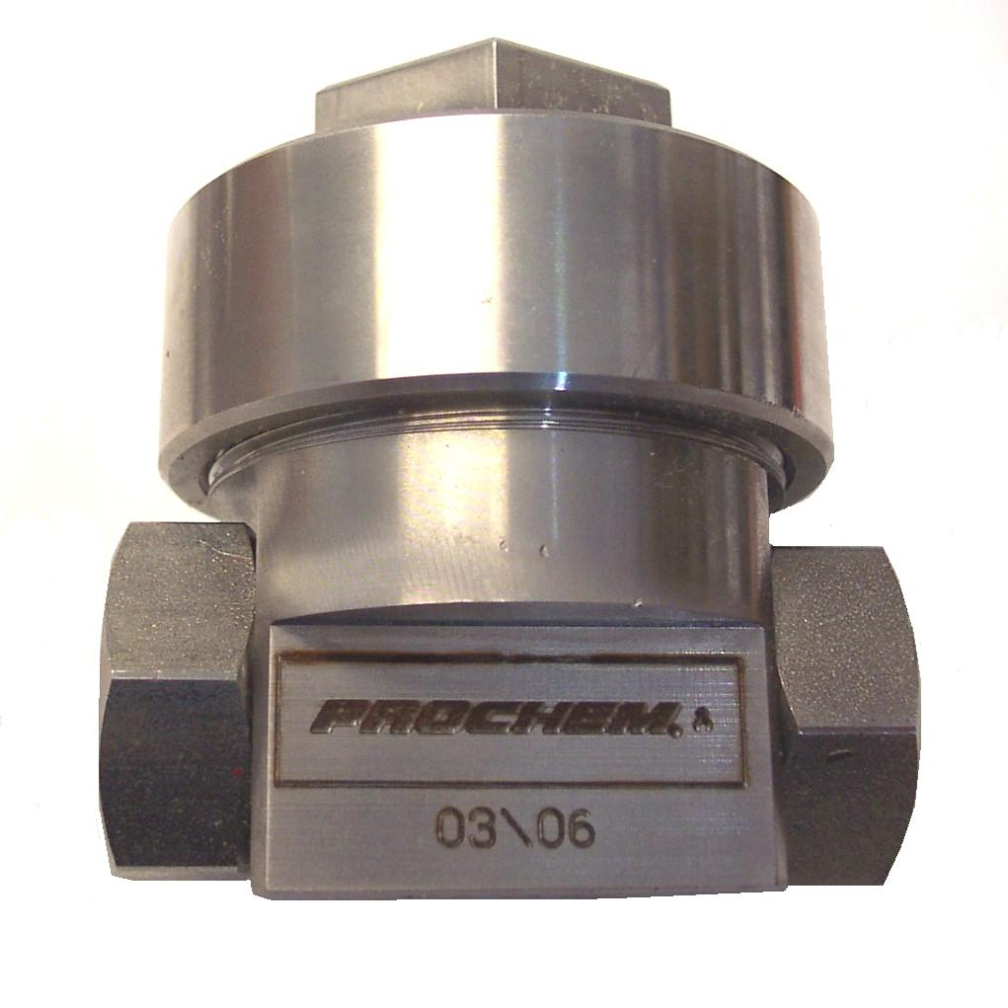

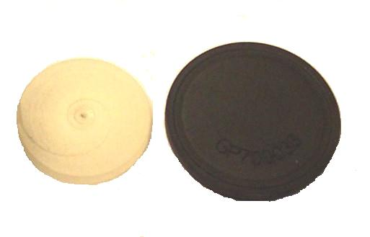

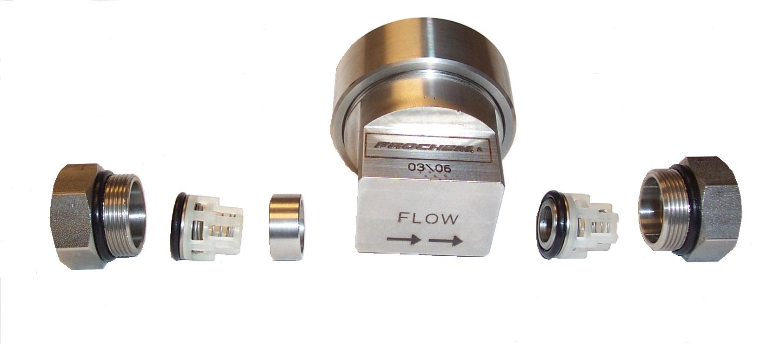

PP42-809047

Diaphragm

PP65252

Disk

PP65250

Cover

PP65253

Body - SS

PP65246

Spacer Ring – Inlet Check Valve

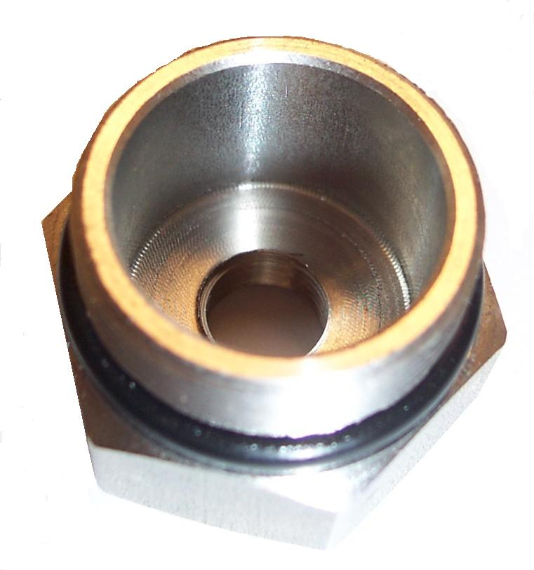
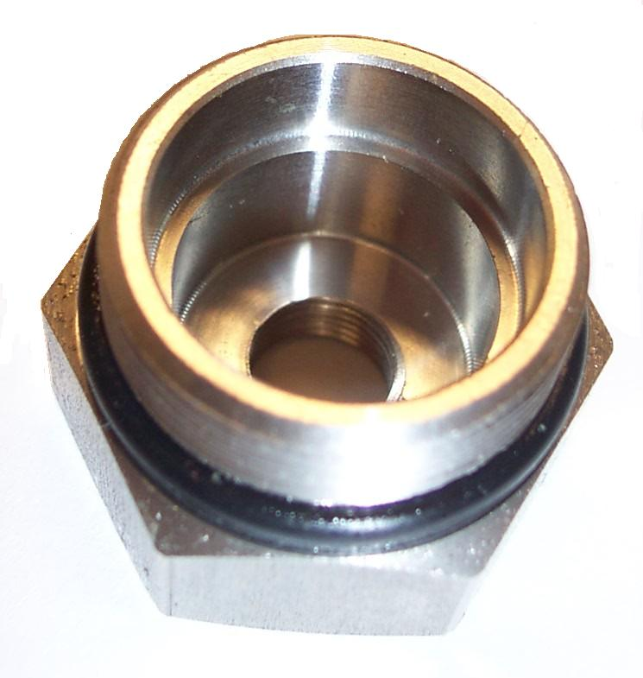

PP65248

Cap – Outlet Check Valve - New Style

PP65245

Cap – Inlet Check Valve - New Style

PP65247

Check Valve with O-ring New Style
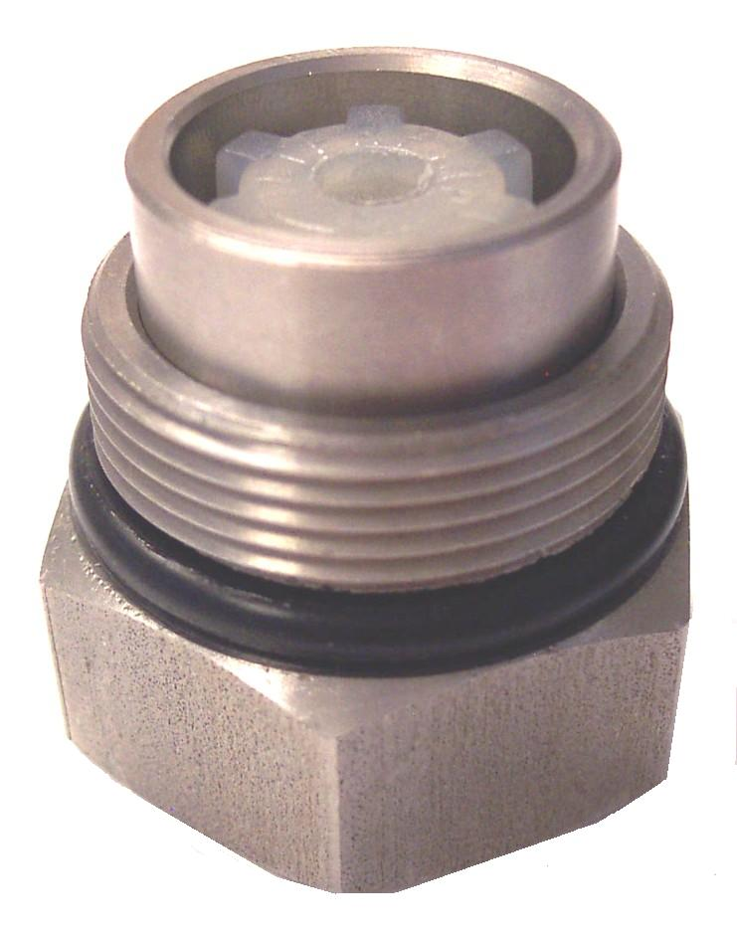
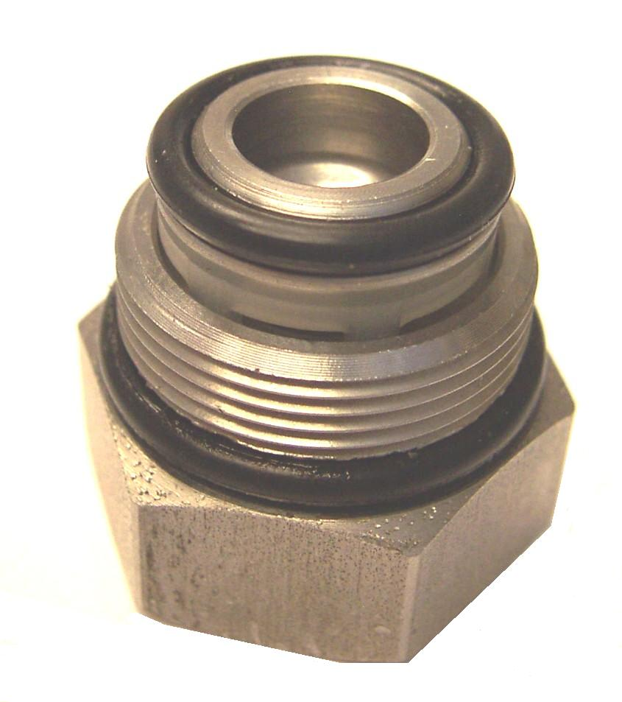

PP43-810079

O-ring Check Valve Cap

Check Valve and Cap

Assemblies
INLET VALVE
ASSEMBLY
OUTLET VALVE ASSEMBLY

*PP16-808237

Cap – Check Valve

Old Style
Bridgepoint Parts Catalog – Truckmount Parts

Section II: Chemical Systems Page 4

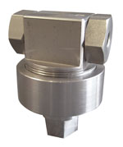

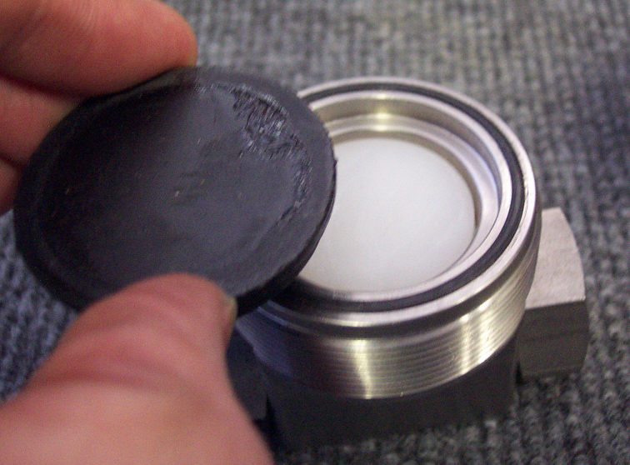

PP43-810105

O-ring Cover Seal

PP42-809264

Disk

PP42-809047

Diaphragm
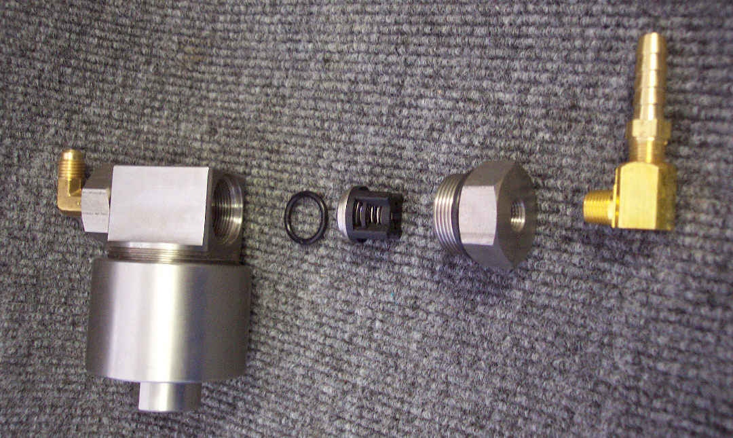

*PP16-808237

Cap – Check Valve

Old Style

PP43-810079

O-ring - Cap

PP42-809265

Check Valve and O-ring

BR280

Elbow 90° Brass

1/8” Street

BR017

Barb 5/16” x 1/8”mpt

Brass

*PP52-502052

Body

Old Style

*PP52-502053

Cover

Old Style
Older stainless steel chemical pumps may have the deeper cover as shown above.

It was replaced by the shallow cover, using the same part number -
PP52-502053.

New style Prochem SS pumps, older brass pumps and similar stainless steel pumps from other vendors may not have the cover seal O-ring.

BR259

Elbow 90° Brass

1/4” Flare x 1/8” mpt
Diaphragms, Disks, Cap O-rings Check valves for older style pumps are still available.

*Many parts for older brass and stainless steel chemical pumps will only be available while supplies last.

Replacing the Old Style Pump with a new pump may be required.

PP42-809265

Check Valve with O-Ring

Chemical Pump - Old Style
(Pumps mfg before March 2006)
(White Magic part #AP005-P)
(Hydramaster part # 169-155)

PP42-809264

Disk – Chemical Pump
Old Style - (Pumps mfg before March 2006)

Prochem – White Magic

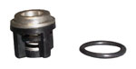
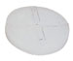
Old Style SS Chemical Pump
No Longer available from Prochem.
Blueline Chemical pump is similar

Bridgepoint Parts Catalog – Truckmount Parts

Section II: Chemical Systems Page 5

PP15-808106

Chemical Metering Valve

1/8” FPT

PP15-808028

Chemical Metering Valve 1/8” FPT

(White Magic part # B086)
(Hydramaster part # 169-160)

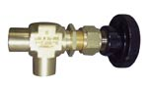
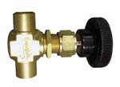

NM3005

3 Way Valve 1/8” FPT

Chemical Prime Valve

(Prochem part # 15-808022)
(White Magic part # B085)

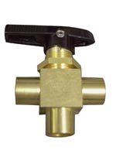

PHY169-017

3 Way Valve 1/8” FPT
Chemical Prime Valve
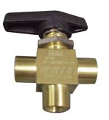

PHY074-020

Chemical Flow Meter
with Knob – Modified

Replacement Knob: PHY061-008

PHY074-028

Chemical Flow Meter- Modified
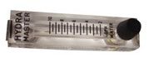
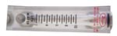

PP18-808513

Chemical Flow Meter

(White Magic part # A019)
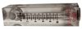

PHY181-008

Venturi – Low PSI Injector

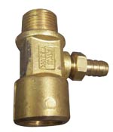

PP18-808522

Chemical Flow Meter

with Knob

(Hydramaster Part # 074-013)
Replacement Knob: PHY061-008

PHY157-022

Switch - Relay

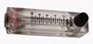
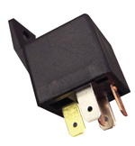

PHY157-0012
Tethered Float Switch
Mercury switch

Hydramaster: Used on older machines for waste tank shut off,
Incoming water solenoid control, low
water shut off switch and pump-out activation.
Bridgepoint: Dagger waste tank shut off, Incoming water solenoid control and pump-out activation.
Can be used as replacement switch for other TM’s.
Update kits are available to replace tethered float on older machines with the newer float systems.
(See PHY157-031 & PHY157-080)

PHY169-120

Solenoid Valve – Water 12VDC

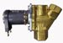
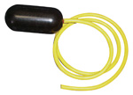

PHY157-031

Float Switch – Side Mount with
Bulkhead fitting

Hydramaster: Control switch for incoming water solenoid on newer
CDS 4.6 & 4.8 with dual float system. CDS 4.8 low water pump clutch switch. Boxxer 421 low water shut off. Many older machines have been updated with the dual float system using this switch. Update kits are still available to replace single float system on older machines with the dual float system.

Dual Float Update Kits
PHY078-114 Spitfire 3.2 & 4.0
PHY078-115 Crossfire 3.7, 4.2 & 4.4
PHY078-308 CDS 4.0, 4.5, 4.2 & 4.7
PHY078-309 CDS 4.8

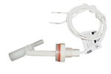

PHY169-062

Valve – Anti-siphon 1/4”

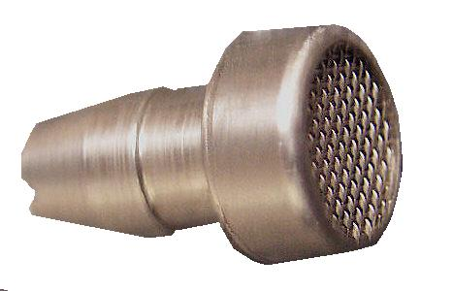

PHY169-061

Valve – Anti-siphon 3/8”

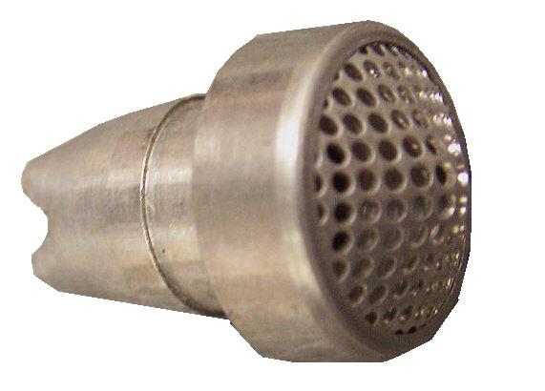

Bridgepoint Parts Catalog – Truckmount Parts

Section II: Chemical Systems Page 6

PP15-808095

Check Valve Manifold Assy. with Check Valve and Filter

Prochem: Bear, Bruin, Bruin II, Performer, Legend, Legend SE, & Trailblazer.
Bridgepoint: Lancer & Saber

Components:
Manifold: PP52-501621
Check Valve Assy.: PP15-808094
Filter: PP14-806549

PP65247

Check Valve with O-Ring

New Style Prochem

Chemical Pump
(Pumps mfg after March 2006)
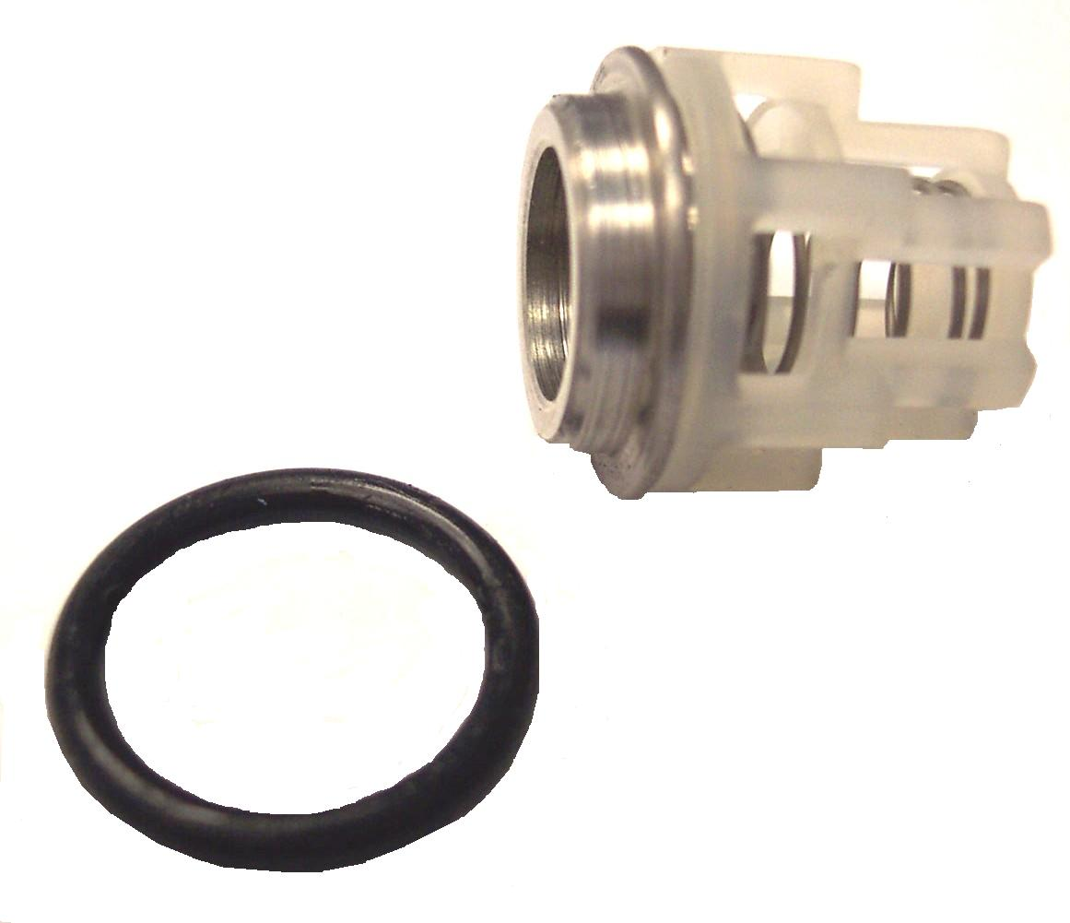
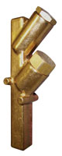

PP42-809047

Diaphragm – Chemical Pump

Prochem, White Magic, Blueline & Hydramaster- SS
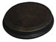

PP65252

Disk – Chemical Pump
(Pumps mfg after March 2006)

New Style Prochem

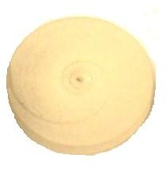

PP15-808094

Check Valve Assembly
Prochem: All machines with check valve manifold assembly.
Bridgepoint: Lancer, Saber & System IV.
Repair Parts:
O-Ring - Seat: PP43-810008
O-Ring – Cap: PP43-810079
Seat: PP16-808223
Spring: PP16-808224
Poppet: PP16-808226
Insert: PP16-808225

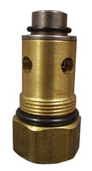

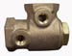

PP15-808032

Check Valve – 1/2” FPT - Brass
(Prochem part # 15-808151)

Prochem: Old style outlet check valve before use of outlet manifold assembly. Cub, CubXL, 800A, 100A, 150 & Oil Fired TM

Repair Parts:
Valve Assembly: PP15-808100
O-Ring - Seat: PP43-810008
O-Ring – Cap: PP43-810079
Seat: PP16-808223
Spring: PP16-808224
Poppet: PP16-808226
Insert: PP16-808225

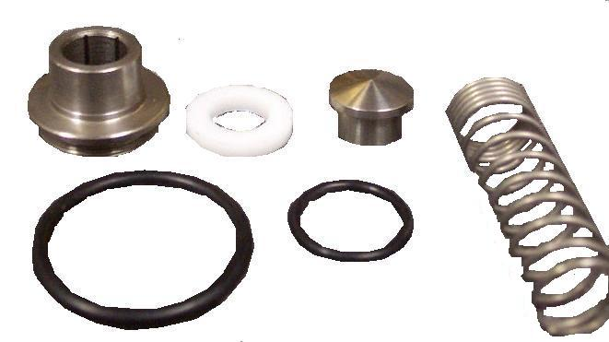

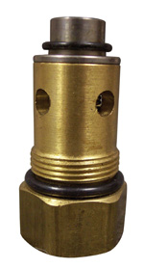

PWM-B221

Check Valve 1/4” F-F

Stainless Steel
White Magic: Chemical Check Valve on all machines

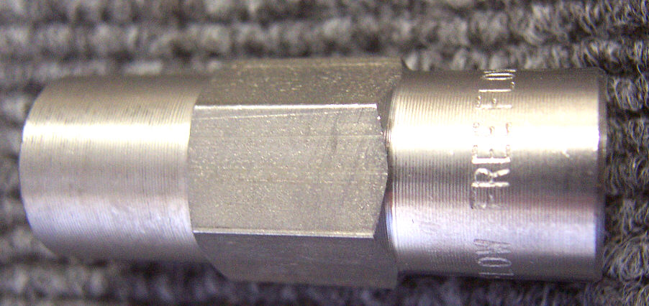

PHY046-010

Diaphragm – Chemical Pump

Hydramaster – Brass Pump
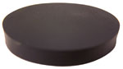
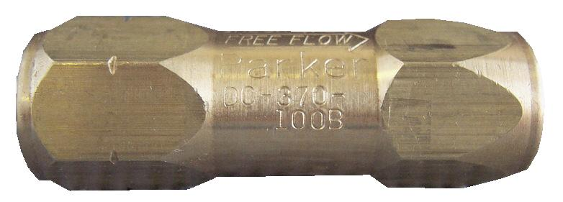

PHY169-175

Check Valve 3/8” F-F – 65psi
Hydramaster: Maxx 450D, Maxx470D and Boxxer 421.
Bridgepoint: Javelin

NA0840

Strainer – Acorn 1/8” FPT
Prochem & White Magic
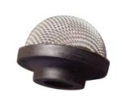

PHY169-186

Check Valve 3/8” F-F 100psi
Hydramaster: CDS 4.6, 4.8 &
Boxxer 427.

PCE290-08

Strainer – Acorn 1/4” FPT
Hydramaster Last Step Injection Systems
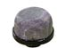

PHY169-025

Check Valve 1/4”

Stainless Steel
Hydramaster: Chemical feed check
valve on old style Hydracat without mix tank.

PP15-808030

Check Valve 1/8” F-M – Brass
Old Style Chemical Pump
Prochem: 100A & 150

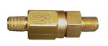

Bridgepoint Parts Catalog – Truckmount Parts

Section II: Chemical Systems Page 7

BR280

Elbow 90° 1/8” Street M-F Brass

BR010

Barb 1/4” x 1/8” MPT

Brass
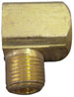
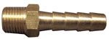

BR282

Elbow 90° 1/4” Street M-F Brass

BR017

Barb 5/16” x 1/8” MPT

Brass
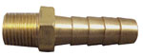
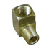

BR284

Elbow 90° 3/8” Street M-F Brass

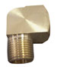

BR018

Barb 3/8” x 1/8” MPT

Brass

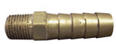

BR030

Barb 1/2” x 3/8” MPT

Brass

BR286

Elbow 90° 1/2” Street M-F Brass

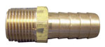

BR074

Hex Nipple 3/8”

Brass

BR294

Elbow 90° 3/8” F-F Brass

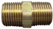
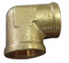

BR259

Elbow 90° 1/4” Flare x 1/8”MPT

Brass

BR080

Close Nipple 1/8”

Brass

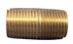
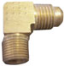

PHY052-019

Swivel Fitting 6m-6ufs

PP12-800261

Elbow 45° 1/4” Flare x 1/8” MPT

Brass

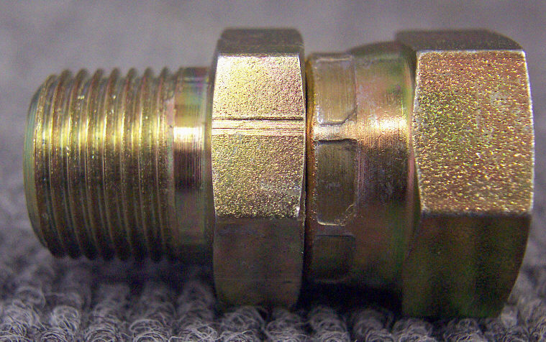
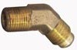

PHY001-082

Adapter – Chemical Pump Mount Cat Pump 5CP & 3CP

Hydra Pump V

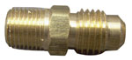

BR124

Coupler 1/4” Flare x 1/8” MPT

Brass

PHY001-096

Adapter – Chemical Pump Mount - Hydra Pump II

PP52-809125

Adapter – Chemical Pump Mount - Cat Pump 5CP & 3CP
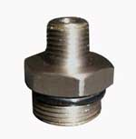

PP790317

Adapter – Chemical Pump Mount - Cat Pump 5CP Plus
Prochem: Everest & Everest HP

XAF1

Tubing 1/4” ID – Vinyl
Hydramaster: Truck mounts with Siphon Chemical systems.
Bridgepoint: Dagger
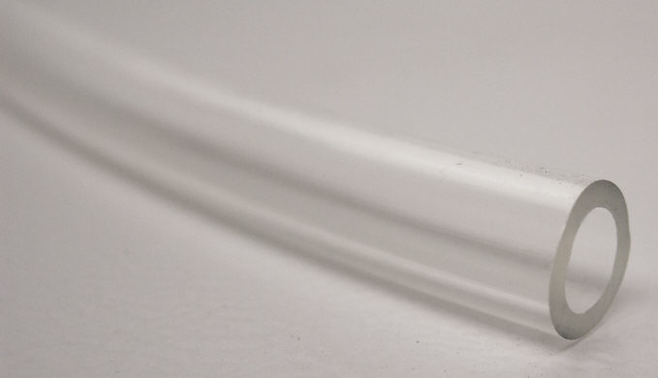
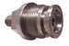

PA053

Hose 3/8” ID – Clear Braided

Hydramaster: TM’s with Last Step Chemical Injection.
Bridgepoint: Javelin

XAF2

Hose 5/16” ID – Clear Braided
Prochem: All Truck mounts.
Bridgepoint: System IV, Saber & Lancer
